SQL interview question:
----------------------------------------------------------------------------------------------------------------
Create a Database in SQL
Explore this section to get hands on all the cheat sheet that help you in order to create a database in SQL.
1. CREATE DATABASE: Create a New Database
CREATE DATABASE company;
This command creates a new database named "company."
2. USE: Select a Specific Database to Work With
USE company;
This command selects the database named "company" for further operations.
3. ALTER DATABASE: Modify a Database's Attributes
ALTER DATABASE database_name
4. DROP DATABASE: Delete an Existing Database
DROP DATABASE company;
Creating Data in SQL
Here in this SQL cheat sheet we have listed down all the cheat sheet that help to create, insert, alter data in table.
5. CREATE: Create a New Table, Database or Index
CREATE TABLE employees (
employee_id INT PRIMARY KEY,
first_name VARCHAR(50),
last_name VARCHAR(50),
department VARCHAR(50),
salary DECIMAL(10, 2)
);
This command creates a table named "employees" with columns for employee ID, first name, last name, department, and salary. The employee_id column is set as the primary key.
6. INSERT INTO: Add New Records To A Table
INSERT INTO employees (employee_id, first_name, last_name, department, salary)
VALUES
(1, 'John', 'Doe', 'HR', 50000.00),
(2, 'Jane', 'Smith', 'IT', 60000.00),
(3, 'Alice', 'Johnson', 'Finance', 55000.00),
(4, 'Bob', 'Williams', 'IT', 62000.00),
(5, 'Emily', 'Brown', 'HR', 48000.00);
This command inserts sample data into the "employees" table with values for employee ID, first name, last name, department, and salary.
7. ALTER TABLE: Modify An Existing Table's Structure
ALTER TABLE employees ADD COLUMN new_column INT;
This command adds a new column named "new_column" of integer type to the existing "employees" table.
8. DROP TABLE: Delete A Table And Its Data
DROP TABLE employees;
This command deletes the entire "employees" table along with all its data.
Reading/Querying Data in SQL
Explore this section to get the cheat sheet on how to use select, distinct and other querying data in SQL.
9. SELECT: Retrieve Data From One Or More Tables
SELECT * FROM employees;
This query will retrieve all columns from the employees table.
10. DISTINCT: Select Unique Values From A Column
SELECT DISTINCT department FROM employees;
This query will return unique department names from the employees table.
11. WHERE: Filter Rows Based On Specified Conditions
SELECT * FROM employees WHERE salary > 55000.00;
This query will return employees whose salary is greater than 55000.00.
12. LIMIT: Limit The Number Of Rows Returned In The Result Set
SELECT * FROM employees LIMIT 3;
This query will limit the result set to the first 3 rows.
13. OFFSET: Skip A Specified Number Of Rows Before Returning The Result Set
SELECT * FROM employees LIMIT 10000 OFFSET 2;
This query retrieves all rows from the "employees" table, skipping the first 2 rows and limiting the result to 10,000 rows.
14. FETCH: Retrieve A Specified Number Of Rows From The Result Set
SELECT * FROM employees FETCH FIRST 3 ROWS ONLY;
This query will fetch the first 3 rows from the result set.

15. CASE: Perform Conditional Logic In A Query
SELECT
first_name,
last_name,
CASE
WHEN salary > 55000 THEN 'High'
WHEN salary > 50000 THEN 'Medium'
ELSE 'Low'
END AS salary_category
FROM employees;
Updating/Manipulating Data in SQL
Get a cheat sheet on how to update or manipulate data in SQL by exploring this section.
16. UPDATE: Modify Existing Records In A Table
UPDATE employees
SET salary = 55000.00
WHERE employee_id = 1;
This query will update the salary of the employee with employee_id 1 to 55000.00.
Deleting Data in SQL
17. DELETE: Remove Records From A Table
DELETE FROM employees
WHERE employee_id = 5;
This query will delete the record of the employee with employee_id 5 from the employees table.
Filtering Data in SQL
18. WHERE: Filter Rows Based On Specified Conditions
SELECT * FROM employees
WHERE department = 'IT';
This query will retrieve all employees who work in the IT department.
19. LIKE: Match A Pattern In A Column
SELECT * FROM employees
WHERE first_name LIKE 'J%';
This query will retrieve all employees whose first name starts with 'J'.
20. IN: Match Any Value In A List
SELECT * FROM employees
WHERE department IN ('HR', 'Finance');
This query will retrieve all employees who work in the HR or Finance departments.
21. BETWEEN: Match Values Within A Specified Range
SELECT * FROM employees
WHERE salary BETWEEN 50000 AND 60000;
This query will retrieve all employees whose salary is between 50000 and 60000.
22. IS NULL: Match NULL Values
SELECT * FROM employees
WHERE department IS NULL;
This query will retrieve all employees where the department is not assigned (NULL).
23. ORDER BY: Sort The Result Set
SELECT * FROM employees
ORDER BY salary DESC;
This query will retrieve all employees sorted by salary in descending order.

SQL Operator:
Here in this section we have added a cheat sheet for SQL Operators. So, explore and learn how to use AND, OR, NOT and others oprtators.
24. AND: Combines Multiple Conditions In A WHERE Clause
SELECT * FROM employees
WHERE department = 'IT' AND salary > 60000;
This query will retrieve employees who work in the IT department and have a salary greater than 60000.
25. OR: Specifies Multiple Conditions Where Any One Of Them Should Be True
SELECT * FROM employees
WHERE department = 'HR' OR department = 'Finance';
This query will retrieve employees who work in either the HR or Finance department.
26. NOT: Negates A Condition
SELECT * FROM employees
WHERE NOT department = 'IT';
This query will retrieve employees who do not work in the IT department.

27. LIKE: Searches For A Specified Pattern In A Column
SELECT * FROM employees WHERE first_name LIKE 'J%';
This query will retrieve employees whose first name starts with 'J'.
28. IN: Checks If A Value Matches Any Value In
SELECT * FROM employees WHERE department IN ('HR', 'Finance');
This query will retrieve employees who work in the HR or Finance departments.
29. BETWEEN: Selects Values Within a Specified Range
SELECT * FROM employees WHERE salary BETWEEN 50000 AND 60000;
This query will retrieve employees whose salary is between 50000 and 60000.
30. IS NULL: Checks if a Value is NULL
SELECT * FROM employees WHERE department IS NULL;
This query will retrieve employees where the department is not assigned (NULL).
31. ORDER BY: Sorts the Result Set in Ascending or Descending Order
SELECT * FROM employees ORDER BY salary DESC;
This query will retrieve all employees sorted by salary in descending order.
32. GROUP BY: Groups Rows that have the Same Values into Summary Rows
SELECT department, COUNT(*) AS employee_count FROM employees GROUP BY department;
This query will group employees by department and count the number of employees in each department

Aggregation Data in SQL
---------------------------------------------------------------
Get an hands in aggregation data in SQL. Here you will find cheat sheet for how to count numbers, sum of numbers and more.
33. COUNT: Count The Number Of Rows In A Result Set
SELECT COUNT(*) FROM employees;
This query will count the total number of employees.
34. SUM: Calculate The Sum Of Values In A Column
SELECT SUM(salary) FROM employees;
This query will calculate the total salary of all employees.
35. AVG: Calculate The Average Value Of A Column
SELECT AVG(salary) FROM employees;
This query will calculate the average salary of all employees.
36. MIN: Find the Minimum Value in a Column
SELECT MIN(salary) FROM employees;
This query will find the minimum salary among all employees.
37. MAX: Find the Maximum Value in a Column
SELECT MAX(salary) FROM employees;
This query will find the maximum salary among all employees.
38. GROUP BY: Group Rows Based on a Specified Column
SELECT department, COUNT(*) AS employee_count
FROM employees
GROUP BY department;
This query will group employees by department and count the number of employees in each department.
39. HAVING: Filter Groups Based on Specified Conditions
SELECT department, AVG(salary) AS avg_salary
FROM employees
GROUP BY department
HAVING AVG(salary) > 55000;
This query will calculate the average salary for each department and return only those departments where the average salary is greater than 55000.

Constraints in SQL:
-----------------------------------
Constraints in SQL act as data quality guardrails, enforcing rules to ensure accuracy, consistency, and integrity within your database tables.
40. PRIMARY KEY: Uniquely Identifies Each Record in a Table
CREATE TABLE employees (
employee_id INT PRIMARY KEY,
first_name VARCHAR(50),
last_name VARCHAR(50)
);
employee_id is designated as the primary key, ensuring that each employee record has a unique identifier.

41. FOREIGN KEY: Establishes a Relationship Between Two Tables
CREATE TABLE departments (
department_id INT PRIMARY KEY,
department_name VARCHAR(50)
);
CREATE TABLE employees (
employee_id INT PRIMARY KEY,
first_name VARCHAR(50),
last_name VARCHAR(50),
department_id INT,
FOREIGN KEY (department_id) REFERENCES departments(department_id)
);
department_id column in the employees table is a foreign key that references the department_id column in the departments table, establishing a relationship between the two tables.

42. UNIQUE: Ensures That All Values in a Column Are Unique
CREATE TABLE employees (
employee_id INT PRIMARY KEY,
email VARCHAR(100) UNIQUE
);
email column must contain unique values for each employee.

43. NOT NULL: Ensures That a Column Does Not Contain NULL Values
CREATE TABLE employees (
employee_id INT PRIMARY KEY,
first_name VARCHAR(50) NOT NULL,
last_name VARCHAR(50) NOT NULL
);
first_name and last_name columns must have values and cannot be NULL.

44. CHECK: Specifies a Condition That Must Be Met for a Column's Value
CREATE TABLE employees (
employee_id INT PRIMARY KEY,
age INT CHECK (age >= 18)
);
age column must have a value of 18 or greater due to the CHECK constraint.

Joins in SQL
Explore different join types to seamlessly merge data from multiple tables in your SQL queries.
45. INNER JOIN: Retrieves Records That Have Matching Values in Both Tables
SELECT * FROM employees
INNER JOIN departments ON employees.department_id = departments.department_id;
This query will retrieve records from both the employees and departments tables where there is a match on the department_id column.
46. LEFT JOIN: Retrieves All Records from the Left Table and the Matched Records from the Right Table
SELECT * FROM employees
LEFT JOIN departments ON employees.department_id = departments.department_id;
This query will retrieve all records from the employees table and only the matching records from the departments table.

47. RIGHT JOIN: Retrieves All Records from the Right Table and the Matched Records from the Left Table
SELECT * FROM employees
RIGHT JOIN departments ON employees.department_id = departments.department_id;
This query will retrieve all records from the departments table and only the matching records from the employees table.
48. FULL OUTER JOIN: Retrieves All Records When There Is a Match in Either the Left or Right Table
SELECT * FROM employees
FULL OUTER JOIN departments ON employees.department_id = departments.department_id;
This query will retrieve all records from both the employees and departments tables, including unmatched records.
49. CROSS JOIN: Retrieves the Cartesian Product of the Two Tables
SELECT * FROM employees
CROSS JOIN departments;
This query will retrieve all possible combinations of records from the employees and departments tables.
50. SELF JOIN: Joins a Table to Itself
SELECT e1.first_name, e2.first_name
FROM employees e1, employees e2
WHERE e1.employee_id = e2.manager_id;
In this example, the employees table is joined to itself to find employees and their respective managers based on the manager_id column.

SQL Functions
In this section we have compiled SQL cheat sheet for SQL functions. It is used for common tasks like aggregation, filtering, date/time manipulation, and more!
51. Scalar Functions: Functions That Return a Single Value
SELECT UPPER(first_name) AS upper_case_name FROM employees;
This query uses the UPPER() scalar function to convert the first_name column values to uppercase.
52. Aggregate Functions: Functions That Operate on a Set of Values and Return a Single Value
SELECT AVG(salary) AS average_salary FROM employees;

SQL Functions
In this section we have compiled SQL cheat sheet for SQL functions. It is used for common tasks like aggregation, filtering, date/time manipulation, and more!
51. Scalar Functions: Functions That Return a Single Value
SELECT UPPER(first_name) AS upper_case_name FROM employees;
This query uses the UPPER() scalar function to convert the first_name column values to uppercase.
52. Aggregate Functions: Functions That Operate on a Set of Values and Return a Single Value
SELECT AVG(salary) AS average_salary FROM employees;
This query uses the AVG() aggregate function to calculate the average salary of all employees.
53. String Functions: Functions That Manipulate String Values
SELECT CONCAT(first_name, ' ', last_name) AS full_name FROM employees;
This query uses the CONCAT() string function to concatenate the first_name and last_name columns into a single column called full_name.
SELECT SUBSTR(first_name, 1, 3) AS short_name FROM employees;
This query uses the SUBSTR() function to extract the first three characters of the first_name column for each employee. The result is displayed in a new column called short_name.
SELECT INSERT(full_name, 6, 0, 'Amazing ') AS modified_name
FROM (SELECT CONCAT(first_name, ' ', last_name) AS full_name FROM employees) AS employee_names;
This query first concatenates the first_name and last_name columns into a single column called full_name. Then, it uses the INSERT() function to insert the string 'Amazing ' at the 6th position of the full_name column for each employee. The modified names are displayed in a new column called modified_name.
54. Date and Time Functions: Functions That Operate on Date and Time Values
SELECT CURRENT_DATE AS current_date FROM dual;
This query uses the CURRENT_DATE date function to retrieve the current date.
55. Mathematical Functions: Functions That Perform Mathematical Operations
SELECT SQRT(25) AS square_root FROM dual;
This query uses the SQRT() mathematical function to calculate the square root of 25.

Subqueries in SQL
This SQL cheat sheet explains how to nest queries for powerful data filtering and manipulation within a single statement.
56. Single-row Subquery: Returns One Row of Result
SELECT first_name, last_name
FROM employees
WHERE salary = (SELECT MAX(salary) FROM employees);
In this example, the subquery (SELECT MAX(salary) FROM employees) returns a single row containing the maximum salary, and it's used to filter employees who have the maximum salary.
57. Multiple-row Subquery: Returns Multiple Rows of Result
SELECT department_name
FROM departments
WHERE department_id IN (SELECT department_id FROM employees);
In this example, the subquery (SELECT department_id FROM employees) returns multiple rows containing department IDs, and it's used to filter department names based on those IDs.
58. Correlated Subquery: References a Column from the Outer Query
SELECT first_name, last_name
FROM employees e
WHERE salary > (SELECT AVG(salary) FROM employees WHERE department = e.department);
In this example, the subquery (SELECT AVG(salary) FROM employees WHERE department = e.department) is correlated with the outer query by referencing the department column from the outer query. It calculates the average salary for each department and is used to filter employees whose salary is greater than the average salary of their respective department.
59. Nested Subquery: A Subquery Inside Another Subquery
SELECT first_name, last_name
FROM employees
WHERE department_id IN (
SELECT department_id
FROM departments
WHERE department_name = 'IT'
);
In this example, the subquery (SELECT department_id FROM departments WHERE department_name = 'IT') is nested within the outer query. It retrieves the department ID for the IT department, which is then used in the outer query to filter employees belonging to the IT department.

Views in SQL
Here in this SQL cheat sheet unveils how to create virtual tables based on existing data for streamlined access.
60. CREATE VIEW: Create a Virtual Table Based on the Result of a SELECT Query
CREATE VIEW high_paid_employees AS
SELECT *
FROM employees
WHERE salary > 60000;
This query creates a views named high_paid_employees that contains all employees with a salary greater than 60000.
61. DROP VIEW: Delete a View
DROP VIEW IF EXISTS high_paid_employees;
This query drops the high_paid_employees view if it exists.
Indexes in SQL
Speed up your SQL queries with our Indexes Cheat Sheet! Learn how to create and optimize indexes to dramatically improve database performance.
62. CREATE INDEX: Create an Index on a Table
CREATE INDEX idx_department ON employees (department);
This query creates an index named idx_department on the department column of the employees table.
63. DROP INDEX: Remove an Index
DROP INDEX IF EXISTS idx_department;
This query drops the idx_department index if it exists.

SQL Views
Views in SQL are a type of virtual table that simplifies how users interact with data across one or more tables. Unlike traditional tables, a view in SQL does not store data on disk; instead, it dynamically retrieves data based on a pre-defined query each time it’s accessed.
SQL views are particularly useful for managing complex queries, enhancing security, and presenting data in a simplified format. In this guide, we will cover the SQL create view statement, updating and deleting views, and using the WITH CHECK OPTION clause.
What is a View in SQL?
A view in SQL is a saved SQL query that acts as a virtual table. It can fetch data from one or more tables and present it in a customized format, allowing developers to:
- Simplify Complex Queries: Encapsulate complex joins and conditions into a single object.
- Enhance Security: Restrict access to specific columns or rows.
- Present Data Flexibly: Provide tailored data views for different users.
We will be using these two SQL tables for examples.
StudentDetails
-- Create StudentDetails table
CREATE TABLE StudentDetails (
S_ID INT PRIMARY KEY,
NAME VARCHAR(255),
ADDRESS VARCHAR(255)
);

INSERT INTO StudentDetails (S_ID, NAME, ADDRESS)
VALUES
(1, 'Harsh', 'Kolkata'),
(2, 'Ashish', 'Durgapur'),
(3, 'Pratik', 'Delhi'),
(4, 'Dhanraj', 'Bihar'),
(5, 'Ram', 'Rajasthan');
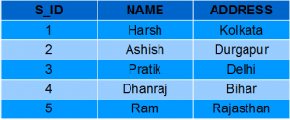
StudentMarks
-- Create StudentMarks table
CREATE TABLE StudentMarks (
ID INT PRIMARY KEY,
NAME VARCHAR(255),
Marks INT,
Age INT
);

INSERT INTO StudentMarks (ID, NAME, Marks, Age)
VALUES
(1, 'Harsh', 90, 19),
(2, 'Suresh', 50, 20),
(3, 'Pratik', 80, 19),
(4, 'Dhanraj', 95, 21),
(5, 'Ram', 85, 18);
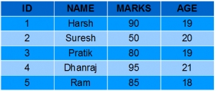
CREATE VIEWS in SQL
We can create a view using CREATE VIEW statement. A View can be created from a single table or multiple tables.
Syntax:
CREATE VIEW view_name AS SELECT column1, column2….. FROM table_name
WHERE condition;
Parameters:
- view_name: Name for the View
- table_name: Name of the table
- condition: Condition to select rows
SQL CREATE VIEW Statement Examples
Let’s look at some examples of CREATE VIEW Statement in SQL to get a better understanding of how to create views in SQL.
Example 1: Creating View From a Single Table
In this example, we will create a View named DetailsView from the table StudentDetails. Query:
CREATE VIEW DetailsView AS
SELECT NAME, ADDRESS
FROM StudentDetails
WHERE S_ID < 5;
To see the data in the View, we can query the view in the same manner as we query a table.
SELECT * FROM DetailsView;
Output:
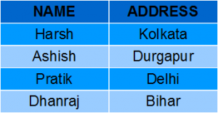
Example 2: Create View From Table
In this example, we will create a view named StudentNames from the table StudentDetails. Query:
CREATE VIEW StudentNames AS
SELECT S_ID, NAME
FROM StudentDetails
ORDER BY NAME;
If we now query the view as,
SELECT * FROM StudentNames;
Output:
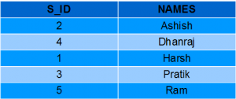
Example 3: Creating View From Multiple Tables
In this example we will create a View named MarksView from two tables StudentDetails and StudentMarks. To create a View from multiple tables we can simply include multiple tables in the SELECT statement. Query:
CREATE VIEW MarksView AS
SELECT StudentDetails.NAME, StudentDetails.ADDRESS, StudentMarks.MARKS
FROM StudentDetails, StudentMarks
WHERE StudentDetails.NAME = StudentMarks.NAME;
To display data of View MarksView:
SELECT * FROM MarksView;
Output:
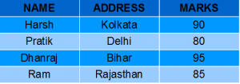

Listing all Views in a Database
We can list View using the SHOW FULL TABLES statement or using the information_schema table. A View can be created from a single table or multiple tables.
Syntax:
USE "database_name";
SHOW FULL TABLES WHERE table_type LIKE "%VIEW";
Using information_schema
SELECT table_name
FROM information_schema.views
WHERE table_schema = 'database_name';
• Retrieves only the names of the views (table_name) in the specified database (database_name).
• Useful if you just need a list of all views in the database
• If you just need to list all views, use the first query.
OR

SELECT table_schema, table_name, view_definition
FROM information_schema.views
WHERE table_schema = 'database_name';

• table_schema: The database name.
• table_name: The name of the view.
• view_definition: The SQL statement that defines the view.
• If you need to examine how views are defined, use the second query.

Delete View in SQL
SQL allows us to delete an existing View. We can delete or drop View using the DROP statement.
Syntax:
DROP VIEW view_name;
Example
In this example, we are deleting the View MarksView.
DROP VIEW MarksView;
Update View in SQL
If you want to update the existing data within the view, use the UPDATE statement.
Syntax:
UPDATE view_name
SET column1 = value1, column2 = value2...., columnN = valueN
WHERE [condition];

Note: Not all views can be updated using the UPDATE statement.
If you want to update the view definition without affecting the data, use the CREATE OR REPLACE VIEW statement. you can use this syntax
CREATE OR REPLACE VIEW view_name AS
SELECT column1, column2, ...
FROM table_name
WHERE condition;

SQL CREATE VIEW Statement Examples
Let’s look at some examples of CREATE VIEW Statement in SQL to get a better understanding of how to create views in SQL.
Example 1: Creating View From a Single Table
In this example, we will create a View named DetailsView from the table StudentDetails. Query:
CREATE VIEW DetailsView AS
SELECT NAME, ADDRESS
FROM StudentDetails
WHERE S_ID < 5;
To see the data in the View, we can query the view in the same manner as we query a table.
SELECT * FROM DetailsView;
Output:


Example 2: Create View From Table
In this example, we will create a view named StudentNames from the table StudentDetails. Query:
CREATE VIEW StudentNames AS
SELECT S_ID, NAME
FROM StudentDetails
ORDER BY NAME;
If we now query the view as,
SELECT * FROM StudentNames;
Output:

Example 3: Creating View From Multiple Tables
In this example we will create a View named MarksView from two tables StudentDetails and StudentMarks. To create a View from multiple tables we can simply include multiple tables in the SELECT statement. Query:

CREATE VIEW MarksView AS
SELECT StudentDetails.NAME, StudentDetails.ADDRESS, StudentMarks.MARKS
FROM StudentDetails, StudentMarks
WHERE StudentDetails.NAME = StudentMarks.NAME;
To display data of View MarksView:
SELECT * FROM MarksView;

Output:

Listing all Views in a Database
We can list View using the SHOW FULL TABLES statement or using the information_schema table. A View can be created from a single table or multiple tables.
Syntax:
USE "database_name";
SHOW FULL TABLES WHERE table_type LIKE "%VIEW";
Using information_schema
SELECT table_name
FROM information_schema.views
WHERE table_schema = 'database_name';

OR

SELECT table_schema, table_name, view_definition
FROM information_schema.views
WHERE table_schema = 'database_name';
Delete View in SQL
SQL allows us to delete an existing View. We can delete or drop View using the DROP statement.
Syntax:
DROP VIEW view_name;
Example
In this example, we are deleting the View MarksView.
DROP VIEW MarksView;
Update View in SQL
If you want to update the existing data within the view, use the UPDATE statement.
Syntax:
UPDATE view_name
SET column1 = value1, column2 = value2...., columnN = valueN
WHERE [condition];
Note: Not all views can be updated using the UPDATE statement.
If you want to update the view definition without affecting the data, use the CREATE OR REPLACE VIEW statement. you can use this syntax
CREATE OR REPLACE VIEW view_name AS
SELECT column1, column2, ...
FROM table_name
WHERE condition;
Rules to Update Views in SQL:
Certain conditions need to be satisfied to update a view. If any of these conditions are not met, the view can not be updated.
- The SELECT statement which is used to create the view should not include GROUP BY clause or ORDER BY clause.
- The SELECT statement should not have the DISTINCT keyword.
- The View should have all NOT NULL values.
- The view should not be created using nested queries or complex queries.
- The view should be created from a single table. If the view is created using multiple tables then we will not be allowed to update the view.
Examples
Let’s look at different use cases for updating a view in SQL. We will cover these use cases with examples to get a better understanding.
Example 1: Update View to Add or Replace a View Field
We can use the CREATE OR REPLACE VIEW statement to add or replace fields from a view.
If we want to update the view MarksView and add the field AGE to this View from StudentMarks Table, we can do this by:
CREATE OR REPLACE VIEW MarksView AS
SELECT StudentDetails.NAME, StudentDetails.ADDRESS, StudentMarks.MARKS, StudentMarks.AGE
FROM StudentDetails, StudentMarks
WHERE StudentDetails.NAME = StudentMarks.NAME;
If we fetch all the data from MarksView now as:
SELECT * FROM MarksView;
Output:
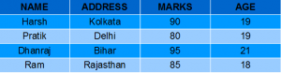
Example 2: Update View to Insert a row in a view
We can insert a row in a View in the same way as we do in a table. We can use the INSERT INTO statement of SQL to insert a row in a View.
In the below example, we will insert a new row in the View DetailsView which we have created above in the example of “creating views from a single table”.
INSERT INTO DetailsView(NAME, ADDRESS)
VALUES("Suresh","Gurgaon");
If we fetch all the data from DetailsView now as,
SELECT * FROM DetailsView;
Output:
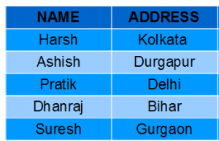
Example 3: Deleting a row from a View
Deleting rows from a view is also as simple as deleting rows from a table. We can use the DELETE statement of SQL to delete rows from a view. Also deleting a row from a view first deletes the row from the actual table and the change is then reflected in the view.
In this example, we will delete the last row from the view DetailsView which we just added in the above example of inserting rows.
DELETE FROM DetailsView
WHERE NAME="Suresh";
If we fetch all the data from DetailsView now as,
SELECT * FROM DetailsView;
Output:

WITH CHECK OPTION Clause
The WITH CHECK OPTION clause in SQL is a very useful clause for views. It applies to an updatable view.
The WITH CHECK OPTION clause is used to prevent data modification (using INSERT or UPDATE) if the condition in the WHERE clause in the CREATE VIEW statement is not satisfied.
If we have used the WITH CHECK OPTION clause in the CREATE VIEW statement, and if the UPDATE or INSERT clause does not satisfy the conditions then they will return an error.
WITH CHECK OPTION Clause Example:
In the below example, we are creating a View SampleView from the StudentDetails Table with a WITH CHECK OPTION clause.
CREATE VIEW SampleView AS
SELECT S_ID, NAME
FROM StudentDetails
WHERE NAME IS NOT NULL
WITH CHECK OPTION;
In this view, if we now try to insert a new row with a null value in the NAME column then it will give an error because the view is created with the condition for the NAME column as NOT NULL. For example, though the View is updatable then also the below query for this View is not valid:
INSERT INTO SampleView(S_ID)
VALUES(6);
NOTE: The default value of NAME column is null.

Uses of a View
A good database should contain views for the given reasons:
- Restricting data access – Views provide an additional level of table security by restricting access to a predetermined set of rows and columns of a table.
- Hiding data complexity – A view can hide the complexity that exists in multiple joined tables.
- Simplify commands for the user – Views allow the user to select information from multiple tables without requiring the users to actually know how to perform a join.
- Store complex queries – Views can be used to store complex queries.
- Rename Columns – Views can also be used to rename the columns without affecting the base tables provided the number of columns in view must match the number of columns specified in a select statement. Thus, renaming helps to hide the names of the columns of the base tables.
- Multiple view facility – Different views can be created on the same table for different users.
Key Takeaways About SQL Views
- Views in SQL are a kind of virtual table.
- The fields in a view can be from one or multiple tables.
- We can create a view using the CREATE VIEW statement and delete a view using the DROP VIEW statement.
- We can update a view using the CREATE OR REPLACE VIEW statement.
- WITH CHECK OPTION clause is used to prevent inserting new rows that do not satisfy the view’s filtering condition.
- DROP INDEX IF EXISTS idx_department;
- This query drops the idx_department index if it exists.

Transactions in SQL
- Learn how to manage groups of database operations as a single unit for reliable data updates.

64. BEGIN TRANSACTION: Start a New Transaction
- BEGIN TRANSACTION;
- This statement starts a new transaction.

65. COMMIT: Save Changes Made During the Current Transaction
- COMMIT;
- This statement saves all changes made during the current transaction.

66. ROLLBACK: Undo Changes Made During the Current Transaction
- ROLLBACK;
- This statement undoes all changes made during the current transaction.
SQL TRANSACTIONS
SQL transactions are essential for ensuring data integrity and consistency in relational databases. Transactions allow for a group of SQL operations to be executed as a single unit, ensuring that either all the operations succeed or none of them do. This capability, together with the ACID (Atomicity, Consistency, Isolation, and Durability) properties, is fundamental for maintaining the integrity of our data.
What is an SQL Transaction?
A transaction in SQL is a sequence of one or more SQL statements executed as a single unit of work. These statements could be performing operations like INSERT, UPDATE, or DELETE. The main idea behind a transaction is that all changes made within it should either be completely successful or fully undone in case of failure. In the case of an error, a rollback ensures that no partial changes are saved.
The SQL transaction must adhere to four key properties known as ACID:
- Atomicity: The outcome of a transaction can either be completely successful or completely unsuccessful. The whole transaction must be rolled back if one part of it fails.
- Consistency: Transactions maintain integrity restrictions by moving the database from one valid state to another.
- Isolation: Concurrent transactions are isolated from one another, assuring the accuracy of the data.
- Durability: Once a transaction is committed, its modifications remain in effect even in the event of a system failure.

The SQL Transaction Process
Transactions are controlled using specific SQL commands. The most common commands used for managing transactions are:
- BEGIN TRANSACTION: Starts a transaction.
- COMMIT: Commits the transaction, saving all changes made.
- ROLLBACK: Rolls back the transaction, undoing all changes made since the BEGIN TRANSACTION.
- SAVEPOINT: Marks a point within a transaction to which you can later roll back.
Example of SQL Transaction with a Bank Transfer Scenario
Let’s look at an example of a bank transfer between two accounts. This example demonstrates the usage of multiple queries in a single transaction.
BEGIN TRANSACTION;
-- Deduct $150 from Account A
UPDATE Accounts
SET Balance = Balance - 150
WHERE AccountID = 'A';
-- Add $150 to Account B
UPDATE Accounts
SET Balance = Balance + 150
WHERE AccountID = 'B';
-- Commit the transaction if both operations succeed
COMMIT;
If any error occurs, such as an issue with the UPDATE query, you can use ROLLBACK to undo all changes made during the transaction:
ROLLBACK;
This ensures that the system doesn’t end up in an inconsistent state, such as deducting money from one account without adding it to another.
SQL Transaction Control Commands
In SQL, transaction control commands manage the execution of SQL operations, ensuring the integrity and reliability of database transactions. These commands help manage the start, commit, and rollback of changes made to the database. Below are the key transaction control commands in SQL, explained with syntax and examples for each.
1. BEGIN TRANSACTION Command
The BEGIN TRANSACTION command marks the beginning of a new transaction. All SQL statements that follow this command will be part of the same transaction until a COMMIT or ROLLBACK is encountered. This command doesn’t make any changes to the database, it just starts the transaction.
Syntax:
BEGIN TRANSACTION transaction_name ;
Example
BEGIN TRANSACTION TransferFunds;
2. COMMIT Command
The COMMIT command is used to save all changes made during the current transaction to the database. Once a transaction is committed, the changes are permanent.
Syntax:
COMMIT;
Here is the sample Student table that will be used to perform the operations in this example. This table contains basic student details such as ID, name, age, and other relevant information that will be manipulated using various transaction control commands.
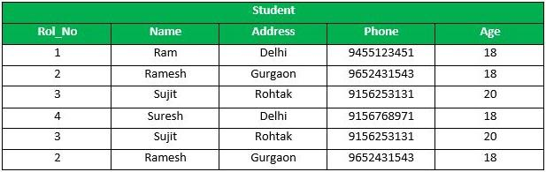
Student Table
Example
Following is an example which would delete those records from the table which have age = 20 and then COMMIT the changes in the database.
DELETE FROM Student WHERE AGE = 20;
COMMIT;
Output
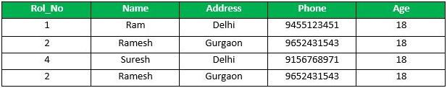
output
3. ROLLBACK Command
The ROLLBACK command is used to undo all changes made in the current transaction. It is used when an error occurs or when the desired changes cannot be completed. The database will revert to the state it was in before the BEGIN TRANSACTION was executed.
Syntax:
ROLLBACK;
Example
Delete those records from the table which have age = 20 and then ROLLBACK the changes in the database. In this case, the DELETE operation is undone, and the changes to the database are not saved.
DELETE FROM Student WHERE AGE = 20;
ROLLBACK;
Output
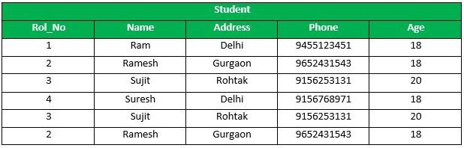
output
4. SAVEPOINT Command
A SAVEPOINT is used to create a checkpoint within a transaction. We can roll back to a specific SAVEPOINT instead of rolling back the entire transaction. This allows us to undo part of the transaction rather than the entire transaction.
Syntax:
SAVEPOINT SAVEPOINT_NAME;
Example
SAVEPOINT SP1;
//Savepoint created.
DELETE FROM Student WHERE AGE = 20;
//deleted
SAVEPOINT SP2;
//Savepoint created.
Output
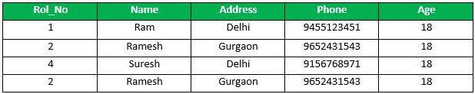
output
Explanation:
From the above example Sample table1, Delete those records from the table which have age = 20 and then ROLLBACK the changes in the database by keeping Savepoints. Here SP1 is first SAVEPOINT created before deletion. In this example one deletion have taken place. After deletion again SAVEPOINT SP2 is created.
5. ROLLBACK TO SAVEPOINT
The ROLLBACK TO SAVEPOINT command allows us to roll back the transaction to a specific savepoint, effectively undoing changes made after that point.
Syntax:
ROLLBACK TO SAVEPOINT SAVEPOINT_NAME;
Example
Deletion have been taken place, let us assume that we have changed our mind and decided to ROLLBACK to the SAVEPOINT that we identified as SP1 which is before deletion. So, In this case the DELETE operation is undone, and the transaction is returned to the state it was in at the SP1 savepoint.
ROLLBACK TO SP1;
//Rollback completed
Output
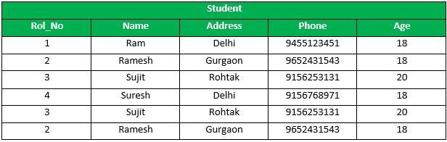
output
6. RELEASE SAVEPOINT Command
This command is used to remove a SAVEPOINT that we have created. Once a SAVEPOINT has been released, we can no longer use the ROLLBACK command to undo transactions performed since the last SAVEPOINT. It is used to initiate a database transaction and used to specify characteristics of the transaction that follows.
Syntax:
RELEASE SAVEPOINT SAVEPOINT_NAME
Example
Once the savepoint SP2 is released, we can no longer roll back to it.
RELEASE SAVEPOINT SP2; -- Release the second savepoint.

Summary of Transaction Control Commands
Command | Purpose | Example
BEGIN TRANSACTION | Starts a new transaction. | BEGIN TRANSACTION TransferFunds;
COMMIT | Saves all changes made during the transaction. | COMMIT;
ROLLBACK | Undoes changes made during the transaction. | ROLLBACK;
SAVEPOINT | Creates a point in the transaction to which you can roll back. | SAVEPOINT SP1;
ROLLBACK TO SAVEPOINT | Rolls back the transaction to a specific savepoint. | ROLLBACK TO SP1;
RELEASE SAVEPOINT | Removes a savepoint from the transaction. | RELEASE SAVEPOINT SP2;

Types of SQL Transactions
There are different types of transactions based on their nature and the specific operations they perform:
- Read Transactions: Used to only read the data, typically with SELECT queries.
- Write Transactions: These involve modifying the data in the database with INSERT, UPDATE, or DELETE operations.
- Distributed Transactions: These transactions span multiple databases and ensure consistency across them.
- Implicit Transactions: Automatically started by SQL Server for certain operations.
- Explicit Transactions: Manually controlled transactions where the user begins and ends the transaction using BEGIN TRANSACTION, COMMIT, and ROLLBACK.
How to Monitor and Optimize SQL Transactions
Optimizing SQL transactions is critical for performance. Here are some best practices:
- Keep Transactions Short: Avoid long-running transactions as they can lock tables and reduce concurrency.
- Use Proper Indexing: Proper indexing on tables involved in the transaction can greatly improve performance.
- Avoid Transaction Blocking: Ensure transactions don’t block others unnecessarily, causing delays.
- Commit Early: Try to commit as soon as the transaction is complete to release resources.

Conclusion
SQL transactions are a fundamental part of database management, providing a way to ensure data consistency, integrity, and isolation. Understanding how to use
BEGIN TRANSACTION, COMMIT, ROLLBACK, and SAVEPOINT is essential for writing reliable and efficient SQL queries. With proper transaction control, we can ensure that our database operations are robust, consistent, and optimized for performance. By following best practices like keeping transactions short and committing early, we can also improve the scalability and concurrency of our database.
FAQs
What is the SQL transaction?
An SQL transaction is a sequence of SQL statements executed as a single unit of work. It ensures that either all operations are successfully completed or none of them are, maintaining the database’s integrity using properties like ACID (Atomicity, Consistency, Isolation, Durability).
What is Transact SQL with an example?
Transact-SQL (T-SQL) is an extension of SQL used in Microsoft SQL Server. It provides additional features such as procedural programming, error handling, and control-of-flow constructs.
Example:
BEGIN TRANSACTION;
UPDATE Employees SET Salary = 60000 WHERE EmployeeID = 1;
COMMIT;
What is the difference between a query and a transaction in SQL?
A query is a single SQL statement used to retrieve or modify data in the database, while a transaction is a series of queries that are executed together to ensure data consistency, with support for commit or rollback in case of errors.
Advanced Mixed Data in SQL
In the last we have complied all the important queries under the one advanced SQL cheat sheet.
67. Stored Procedures: Precompiled SQL Statements That Can Be Executed with a Single Command
CREATE PROCEDURE get_employee_count()
BEGIN
SELECT COUNT(*) FROM employees;
END;
SQL Stored Procedures are a powerful feature in database management systems (DBMS) that allow developers to encapsulate SQL code and business logic. Stored procedures are precompiled SQL statements that are stored in the database and can be executed as a single unit.
What is a SQL Stored Procedure?
A SQL Stored Procedure is a collection of SQL statements bundled together to perform a specific task. These procedures are stored in the database and can be called upon by users, applications, or other procedures. Stored procedures are essential for automating database tasks, improving efficiency, and reducing redundancy. By encapsulating logic within stored procedures, developers can streamline their workflow and enforce consistent business rules across multiple applications and systems.
Syntax:
CREATE PROCEDURE procedure_name
(parameter1 data_type, parameter2 data_type, …)
AS
BEGIN
— SQL statements to be executed
END
Key Terms
- CREATE PROCEDURE: This keyword creates the stored procedure with the given name.
- @parameter1, @parameter2: These are input parameters that allow you to pass values into the stored procedure.
- BEGIN...END: These keywords define the block of SQL statements that make up the procedure body.

Why Use SQL Stored Procedures?
- Performance Optimization: Since stored procedures are precompiled, they execute faster than running ad-hoc SQL queries. The database engine can reuse the execution plan, eliminating the need for repeated query parsing and optimization.
- Security: By using stored procedures, developers can restrict direct access to sensitive data. Users can execute procedures without accessing the underlying tables, helping to protect critical information.
- Code Reusability: SQL stored procedures can be reused in multiple applications or different parts of an application. This reduces the need to rewrite complex queries repeatedly.
- Reduced Network Traffic: Instead of sending multiple individual queries to the database server, stored procedures allow you to execute multiple operations in one go, reducing network load.
- Maintainability: Stored procedures simplify code maintenance. Changes made to the procedure are automatically reflected wherever the procedure is used, making it easier to manage complex logic.
By passing a country as a parameter, the stored procedure dynamically fetches the relevant customer details from the table------------------------------
Create a stored procedure named "GetCustomersByCountry"
CREATE PROCEDURE GetCustomersByCountry
@Country VARCHAR(50)
AS
BEGIN
SELECT CustomerName, ContactName
FROM Customers
WHERE Country = @Country;
END;
-- Execute the stored procedure with parameter "Sri Lanka"
EXEC GetCustomersByCountry @Country = 'Sri lanka';
A stored procedure in SQL is a set of precompiled SQL statements that can be executed as a single unit. It is stored in the database and can be invoked to perform various tasks, such as data manipulation, executing queries, and automating repetitive operations.
Types of SQL Stored Procedures
SQL stored procedures are categorized into different types based on their use case and functionality:
- System Stored Procedures: These are predefined stored procedures provided by the SQL Server for performing administrative tasks. Examples include sp_help for viewing database object information and sp_rename for renaming database objects.
- User-Defined Stored Procedures: These are custom stored procedures created by the user to perform specific operations. For example, creating a procedure that calculates the total sales for a particular product category.
- Extended Stored Procedures: These allow for the execution of external functions, which might be implemented in other languages such as C or C++. Extended procedures are typically used for integrating external tools into SQL Server.
- CLR Stored Procedures: These are stored procedures written in .NET languages (like C#) and executed within SQL Server. CLR stored procedures are useful when advanced functionality is needed that isn’t easily achievable with T-SQL alone

68. Triggers: Automatically Execute a Set of SQL Statements When a Specified Event Occurs
CREATE TRIGGER before_employee_insert
BEFORE INSERT ON employees
FOR EACH ROW
BEGIN
SET NEW.creation_date = NOW();
END;
SQL triggers are a critical feature in database management systems (DBMS) that provide automatic execution of a set of SQL statements when specific database events, such as INSERT, UPDATE, or DELETE operations, occur. Triggers are commonly used to maintain data integrity, track changes, and enforce business rules automatically, without needing manual input.
What is SQL Trigger?
A trigger is a stored procedure in a database that automatically invokes whenever a special event in the database occurs. By using SQL triggers, developers can automate tasks, ensure data consistency, and keep accurate records of database activities. For example, a trigger can be invoked when a row is inserted into a specified table or when specific table columns are updated.
In simple words, a trigger is a collection of SQL statements with particular names that are stored in system memory. It belongs to a specific class of stored procedures that are automatically invoked in response to database server events. Every trigger has a table attached to it.
Key Features of SQL Triggers:
- Automatic Execution: Triggers fire automatically when the defined event occurs (e.g., INSERT, UPDATE, DELETE).
- Event-Driven: Triggers are tied to specific events that take place within the database.
- Table Association: A trigger is linked to a specific table or view, and operates whenever changes are made to the table’s data.
Syntax
create trigger [trigger_name]
[before | after]
{insert | update | delete}
on [table_name]
FOR EACH ROW
BEGIN
//sql statement body
END;

Key Terms
- trigger_name: The name of the trigger to be created.
- BEFORE | AFTER: Specifies whether the trigger is fired before or after the triggering event (INSERT, UPDATE, DELETE).
- {INSERT | UPDATE | DELETE}: Specifies the operation that will activate the trigger.
- table_name: The name of the table the trigger is associated with.
- FOR EACH ROW: Indicates that the trigger is row-level, meaning it executes once for each affected row.
- trigger_body: The SQL statements to be executed when the trigger is fired.

Types of SQL Triggers
Triggers can be categorized into different types based on the action they are associated with:

1. DDL Triggers
The Data Definition Language (DDL) command events such as Create_table, Create_view, drop_table, Drop_view,and Alter_table
cause the DDL triggers to be activated. They allow us to track changes in the structure of the database. The trigger will prevent any table creation, alteration, or deletion in the database.
Example:
CREATE TRIGGER prevent_table_creation
ON DATABASE
FOR CREATE_TABLE, ALTER_TABLE, DROP_TABLE
AS
BEGIN
PRINT 'you can not create, drop and alter table in this database';
ROLLBACK;
END;

2. DML Triggers
The Data manipulation Language (DML) command events that begin with Insert, Update, and Delete set off the DML triggers. DML triggers are used for data validation, ensuring that modifications to a table are done under controlled conditions.
Example:
CREATE TRIGGER prevent_update
ON students
FOR UPDATE
AS
BEGIN
PRINT 'You can not insert, update and delete this table i';
ROLLBACK;
END;
3. Logon Triggers
These triggers are fired in response to logon events. Logon triggers are useful for monitoring user sessions or restricting user access to the database. As a result, the PRINT statement messages and any errors generated by the trigger will all be visible in the SQL Server error log. Authentication errors prevent logon triggers from being used. These triggers can be used to track login activity or set a limit on the number of sessions that a given login can have in order to audit and manage server sessions.
Example:
CREATE TRIGGER track_logon
ON LOGON
AS
BEGIN
PRINT 'A new user has logged in.';
END;

Using SQL Triggers: Practical Use Cases
1. Automatically Updating Related Tables (DML Trigger Example)
Triggers can automatically perform tasks, like updating related tables when data changes. For instance, when a student’s grade is updated, the total score in the related table can also be updated automatically.
Example:
CREATE TRIGGER update_student_score
AFTER UPDATE ON student_grades
FOR EACH ROW
BEGIN
UPDATE total_scores
SET score = score + :new.grade
WHERE student_id = :new.student_id;
END;
2. Data Validation (Before Insert Trigger Example)
Triggers can be used to validate data before it is inserted into a table, ensuring that the data follows specific business rules.
Example:
CREATE TRIGGER validate_grade
BEFORE INSERT ON student_grades
FOR EACH ROW
BEGIN
IF :new.grade < 0 OR :new.grade > 100 THEN
RAISE_APPLICATION_ERROR(-20001, 'Invalid grade value.');
END IF;
END;
Output
This trigger ensures that no grade less than 0 or greater than 100 is inserted into the student_grades table.

Viewing Triggers in SQL
If we are working with many tables across multiple databases, we can use a simple query to list all available triggers in our SQL Server instance. This is helpful for tracking and managing triggers, especially when dealing with tables that have similar names across databases.
Syntax
SELECT name, is_instead_of_trigger
FROM sys.triggers
WHERE type = ‘TR’;
Key Terms
- name: The name of the trigger.
- is_instead_of_trigger: Whether the trigger is an INSTEAD OF trigger.
- type = ‘TR’: This filters the results to show only triggers.
The SQL Server Management Studio makes it very simple to display or list all triggers that are available for any given table. The following steps will help us accomplish this:
Go to the Databases menu, select the desired database, and then expand it.
- Select the Tables menu and expand it.
- Select any specific table and expand it.
- We will get various options here. When we choose the Triggers option, it displays all the triggers available in this table.

BEFORE and AFTER Triggers
SQL triggers can be specified to run BEFORE or AFTER the triggering event.
- BEFORE Triggers: Execute before the actual SQL statement is executed. Useful for validating data before insertion or updating.
- AFTER Triggers: Execute after the SQL statement completes. Useful for logging or cascading updates to other tables.
Example: Using BEFORE Trigger for Calculations
Given Student Report Database, in which student marks assessment is recorded. In such a schema, create a trigger so that the total and percentage of specified marks are automatically inserted whenever a record is inserted. Here, a trigger will invoke before the record is inserted so BEFORE Tag can be used.
Query
mysql>>desc Student;
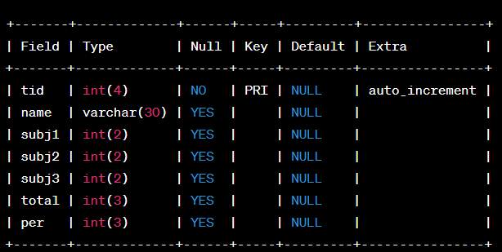
Student Datatype
Below SQL statement will create a trigger in the student database in which whenever subjects marks are entered, before inserting this data into the database, the trigger will compute those two values and insert them with the entered values. In this way, triggers can be created and executed in the databases.
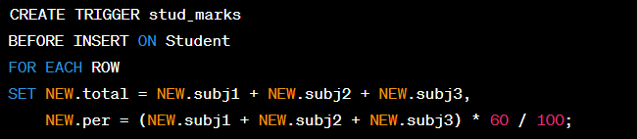
Stud_marks
Output
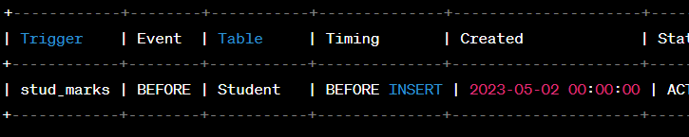
Output
Advantages of Triggers
- Data Integrity: Triggers help enforce consistency and business rules, ensuring that data follows the correct format.
- Automation: Triggers eliminate the need for manual intervention by automatically performing tasks such as updating, inserting, or deleting records when certain conditions are met.
- Audit Trail: Triggers can track changes in a database, providing an audit trail of INSERT, UPDATE, and DELETE operations.
- Performance: By automating repetitive tasks, triggers improve SQL query performance and reduce manual workload.

FAQs
What is an SQL trigger?
An SQL trigger is a special type of stored procedure that automatically executes or fires when certain events occur in a database, such as INSERT, UPDATE, or DELETE on a table.
How do SQL triggers work?
SQL triggers work by being automatically invoked in response to specific actions (like data modifications) on a table or view, based on the event, timing (before or after), and condition specified in the trigger definition.
What are the benefits of using SQL triggers?
SQL triggers help ensure data integrity, enforce business rules, and automatically audit changes in the database. They reduce the need for repetitive manual tasks and improve consistency and security in database operations.
69. User-defined Functions (UDFs): Custom SQL Functions Created by Users to Perform Specific Tasks
CREATE FUNCTION calculate_bonus(salary DECIMAL) RETURNS DECIMAL
BEGIN
RETURN salary * 0.1; -- 10% bonus
END;
This query creates a user-defined function named calculate_bonus that calculates the bonus based on the salary.

Scenario:
A company wants to calculate performance-based bonuses for its employees. The bonus is 10% of the salary by default, but if an employee has more than 5 years of experience, the bonus increases to 15%.
DELIMITER $$
CREATE FUNCTION calculate_bonus(salary DECIMAL(10,2), years_of_experience INT)
RETURNS DECIMAL(10,2)
DETERMINISTIC
BEGIN
DECLARE bonus DECIMAL(10,2);
IF years_of_experience > 5
THEN
SET bonus = salary * 0.15; -- 15% bonus for experienced employees
ELSE
SET bonus = salary * 0.10; -- 10% bonus for others
END IF;
RETURN bonus;
END $$
DELIMITER ;

2️ Using the UDF in a Query
Suppose we have an Employees table with columns EmployeeID, Name, Salary, and YearsOfExperience.
We can use our calculate_bonus() function to determine the bonus for each employee.
SELECT EmployeeID, Name, Salary, YearsOfExperience, calculate_bonus(Salary, YearsOfExperience) AS Bonusn FROM Employees
Example 1: Calculate Tax Based on Salary Slabs
Scenario: A company wants to calculate income tax based on salary slabs:
- Salary ≤ 50,000 → 5% tax
- Salary between 50,001 and 100,000 → 10% tax
- Salary > 100,000 → 15% tax
DELIMITER $$
CREATE FUNCTION calculate_tax(salary DECIMAL(10,2))
RETURNS DECIMAL(10,2) DETERMINISTIC
BEGIN
DECLARE tax DECIMAL(10,2);
IF salary <= 50000 THEN
SET tax = salary * 0.05;
ELSEIF salary <= 100000 THEN
SET tax = salary * 0.10;
ELSE
SET tax = salary * 0.15;
END IF;
RETURN tax;
END
$$ DELIMITER ;
Using the Function in a Query
SELECT EmployeeID, Name, Salary, calculate_tax(Salary) AS Tax FROM Employees;
Example 2: Calculate Discount Based on Purchase Amount
Scenario: An e-commerce platform wants to offer discounts based on total purchase value: DECIMAL(10,2) means: 10 → Maximum total digits (including before and after decimal).2 → Maximum digits after the decimal point.1)< 5000 → No discount, 2)5,000 - 10,000 → 5% discount,
3)10,001 - 20,000 → 10% discount,4)> 20,000 → 15% discount
DELIMITER $$
CREATE FUNCTION calculate_discount(amount DECIMAL(10,2))
RETURNS DECIMAL(10,2) DETERMINISTIC
BEGIN
DECLARE discount DECIMAL(10,2);
IF amount < 5000 THEN
SET discount = 0;
ELSEIF amount BETWEEN 5000 AND 10000 THEN
SET discount = amount * 0.05;
ELSEIF amount BETWEEN 10001 AND 20000 THEN
SET discount = amount * 0.10;
ELSE
SET discount = amount * 0.15;
END IF;
RETURN discount;
END
$$DELIMITER ;
Using the Function in a Query
SELECT OrderID, CustomerName, TotalAmount, calculate_discount(TotalAmount) AS Discount FROM Orders;
Example 3: Calculate Student Grade Based on Marks
Scenario:A school wants to assign grades to students based on their marks:
- Marks ≥ 90 → Grade A
- Marks 80-89 → Grade B
- Marks 70-79 → Grade C
- Marks 60-69 → Grade D
- Marks < 60 → Grade F
DELIMITER $$
CREATE FUNCTION get_grade(marks INT)
RETURNS CHAR(1) DETERMINISTIC
BEGIN
DECLARE grade CHAR(1);
IF marks >= 90 THEN
SET grade = 'A';
ELSEIF marks >= 80 THEN
SET grade = 'B';
ELSEIF marks >= 70 THEN
SET grade = 'C';
ELSEIF marks >= 60 THEN
SET grade = 'D';
ELSE
SET grade = 'F';
END IF;
RETURN grade;
END
$$ DELIMITER ;
Using the Function in a Query
SELECT StudentID, Name, Marks, get_grade(Marks) AS Grade FROM Students
70. Common Table Expressions (CTEs): Temporary Result Sets That Can Be Referenced Within a SELECT, INSERT, UPDATE, or DELETE Statement
WITH high_paid_employees AS (
SELECT * FROM employees WHERE salary > 60000
)
SELECT * FROM high_paid_employees;
This query uses a common table expression named high_paid_employees to retrieve all employees with a salary greater than 60000.
In SQL, a Common Table Expression (CTE) is an essential tool for simplifying complex queries and making them more readable. By defining temporary result sets that can be referenced multiple times, a CTE in SQL allows developers to break down complicated logic into manageable parts. CTEs help with hierarchical data representation, improve code reusability, and simplify maintenance
Why do We Need CTE in the SQL ?
A Common Table Expression (CTE) in SQL is a temporary result set that is defined and used within the execution scope of a SELECT, INSERT, UPDATE,or DELETE statement. CTEs are defined using the WITH clause and can be referenced multiple times within the main SQL query. This makes CTEs a great alternative to subqueries, especially in cases where we need to perform the same operation multiple times or create recursive queries.

Why Use CTEs in SQL?
CTEs simplify query writing and maintenance by:
- Breaking down complex queries into smaller, reusable components.
- Improving code readability and modularity.
- Enabling recursive operations for hierarchical data.
Syntax
WITH cte_name AS (
SELECT query
)
SELECT * FROM cte_name;
Key Terms
- cte_name: A unique name for the CTE expression.
- query: A valid SQL query that returns a result set, which will be treated as a virtual table within the main query.
- SELECT: The main query that can reference the CTE by its name.
Creating a Simple CTE in SQL
Let’s consider an Employees table that contains employee details such as EmployeeID, Name, Department, Salary, and ManagerID. This table is used to demonstrate how to use a Common Table Expression (CTE) to simplify SQL queries, particularly when aggregating or filtering data.
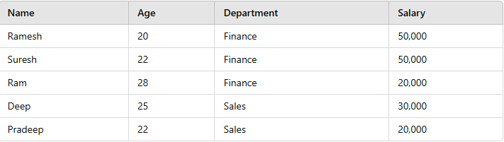

Employees table
Example: Calculate Average Salary by Department
In this example, we will use a Common Table Expression (CTE) to calculate the average salary for each department in the Employees table. The CTE simplifies the query by breaking it into a manageable part that can be referenced in the main query.
Query:
WITH AvgSalaryByDept AS (
SELECT Department, AVG(Salary) AS AvgSalary FROM Employees
GROUP BY Department
)
SELECT * FROM AvgSalaryByDept;
Output
Department | AvgSalary
IT | 75000
HR | 60000
Finance | 52500
Explanation:
- The WITH clause defines a CTE named AvgSalaryByDept.
- The main query references this CTE to retrieve the average salary for each department.

Recursive Common Table Expression (RCTE)
A recursive CTE is one that references itself within that CTE. The recursive CTE is useful when working with hierarchical data as the CTE continues to execute until the query returns the entire hierarchy.
A typical example of hierarchical data is a table that includes a list of employees. For every employee, the table provides a reference to that person’s manager. That reference is itself an employee ID within the same table. We can use a recursive CTE to display the hierarchy of employee data.
If a CTE is created incorrectly it can enter an infinite loop. To prevent this, the MAXRECURSION hint can be added in the OPTION clause of the primary SELECT, INSERT, UPDATE, DELETE, or MERGE statement.
Example: Hierarchical Employee Data
WITH cteReports (EmpID, FirstName, LastName, MgrID, EmpLevel)
AS
(
SELECT EmployeeID, FirstName, LastName, ManagerID, 1
FROM Employees
WHERE ManagerID IS NULL
UNION ALL
SELECT e.EmployeeID, e.FirstName, e.LastName, e.ManagerID,
r.EmpLevel + 1
FROM Employees e
INNER JOIN cteReports r
ON e.ManagerID = r.EmpID
)
SELECT
FirstName + ' ' + LastName AS FullName,
EmpLevel, (SELECT FirstName + ' ' + LastName FROM Employees
WHERE EmployeeID = cteReports.MgrID) AS Manager FROM cteReports
ORDER BY EmpLevel, MgrID

Output
Name | Level
John Smith | 1
Jane Doe | 2
Alice Brown | 2
Bob Green | 3
Charlie Ray | 3
📊 Sample Data & Output Example
🔹 Employees Table
EmployeeID | FirstName | LastName | ManagerID
1 | Alice | Smith | NULL
2 | Bob | Johnson | 1
3 | Charlie | Brown | 1
4 | David | Lee | 2
5 | Emma | Wilson | 2
6 | Frank | Taylor | 3

🔹 Query Output
FullName | EmpLevel | Manager
Alice Smith | 1 | NULL
Bob Johnson | 2 | Alice Smith
Charlie Brown | 2 | Alice Smith
David Lee | 3 | Bob Johnson
Emma Wilson | 3 | Bob Johnson
Frank Taylor | 3 | Charlie Brown

Explanation:
- The anchor member selects employees with no manager (ManagerID IS NULL), establishing the base level.
- The recursive member joins the CTE to the table, incrementing the level for each subordinate employee.
Benefits of Using CTEs in SQL
- Improved Readability: CTEs help break down complex queries into modular, reusable components, improving code readability and maintainability.
- Reusability: Once defined, a CTE can be referenced multiple times within the same query, reducing the need for repetitive code.
- Simplifies Complex Queries: By using CTEs, especially recursive CTEs, complex operations like hierarchical data queries become much easier to manage.
- Query Optimization: SQL engines can optimize queries that use CTEs more efficiently, improving performance, especially when the same result set needs to be accessed multiple times.
Limitations of CTEs in SQL
- Temporary Scope: A CTE exists only during the execution of the query. Once the query completes, the CTE is discarded.
- Performance Issues: For very large datasets, CTEs can sometimes lead to performance degradation due to multiple references to the same CTE.
- Not Allowed in All Database Operations: Some operations, such as INSERT and UPDATE, may have restrictions when using CTEs in certain databases.

- Common Table Expressions (CTEs) are a valuable feature in SQL, enhancing query readability, modularity, and performance. By using CTEs, developers can simplify complex queries, especially those involving hierarchical data or repeated subqueries.

CTE vs Subqueries
Feature | CTE | Subquery
Reusability | Can be referenced multiple times. | Typically used once.
Readability | Improves readability for complex queries. | Can become difficult to read when nested.
Performance | Optimized for multiple references. | May be less efficient for repeated operations.
FAQs
What is a CTE in SQL?
A CTE (Common Table Expression) in SQL is a temporary result set defined within the execution scope of a SELECT, INSERT, UPDATE, or DELETE statement. It simplifies complex queries by allowing you to break them into reusable subqueries that improve readability and maintainability.
What is CTE in SQL interview questions?
In SQL interviews, a CTE is commonly discussed to assess a candidate’s understanding of query optimization and the ability to handle complex querie ,the use of CTEs for breaking down subqueries, improving performance, and organizing SQL code effectively.
What is the difference between CTE and subquery?
A CTE is defined before the main query and can be referenced multiple times, improving readability and reusability. A subquery, on the other hand, is embedded within a query and can only be referenced once. CTEs tend to be easier to debug and maintain compared to subqueries, especially in complex SQL operations.

Window Functions in SQL:
SQL window functions are essential for advanced data analysis and database management. They enable calculations across a specific set of rows, known as a “window,” while retaining the individual rows in the dataset. Unlike traditional aggregate functions that summarize data for the entire group, window functions allow detailed calculations for specific partitions or subsets of data.
This article provides a detailed explanation of SQL window functions, including the OVER clause, partitioning, ordering, and practical use cases, complete with outputs to help us understand their behaviour.
What is a Window Function in SQL?
A window function in SQL is a type of function that allows us to perform calculations across a specific set of rows related to the current row. These calculations happen within a defined window of data, and they are particularly useful for aggregates, rankings, and cumulative totals without altering the dataset.
The OVER clause is key to defining this window. It partitions the data into different sets (using the PARTITION BY clause) and orders them (using the ORDER BY clause). These windows enable functions like SUM(), AVG(), ROW_NUMBER(), RANK(), and DENSE_RANK() to be applied in a sophisticated manner.
Syntax :SELECT column_name1, window_function (column_name2)
OVER ([PARTITION BY column_name1] [ORDER BY column_name3]) AS new_column FROM table_name;
Key Terms
- window_function= any aggregate or ranking function
- column_name1= column to be selected
- column_name2= column on which window function is to be applied
- column_name3= column on whose basis partition of rows is to be done
- new_column= Name of new column
- table_name= Name of table

Types of Window Functions in SQL

SQL window functions can be categorized into two primary types: aggregate window functions and ranking window functions. These two types serve different purposes but share a common ability to perform calculations over a defined set of rows while retaining the original data. The employee table contains details about employees, such as their name, age, department, and salary.
employees Table

1. Aggregate Window Function
Aggregate window functions calculate aggregates over a window of rows while retaining individual rows. These include SUM(), AVG(), COUNT(), MAX(), and MIN().
Example: AVG() Function
Query to calculate the average salary within each department:
SELECT Name, Age, Department, Salary,
AVG(Salary) OVER( PARTITION BY Department) AS Avg_Salary
FROM employee
Output
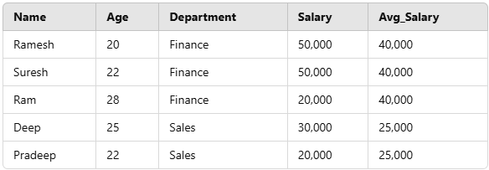
AVG() Function Example
Explanation:
- The AVG() function calculates the average salary for each department using the PARTITION BY Department clause.
- The average salary is repeated for all rows in the respective department.
2. Ranking Window Functions
These functions provide rankings of rows within a partition based on specific criteria. Common ranking functions include:
1. RANK() Function
The RANK() function assigns ranks to rows within a partition, with the same rank given to rows with identical values. If two rows share the same rank, the next rank is skipped.
Example:
SELECT Name, Department, Salary,
RANK() OVER(PARTITION BY Department ORDER BY Salary DESC AS emp_rank FROM employee;
Output
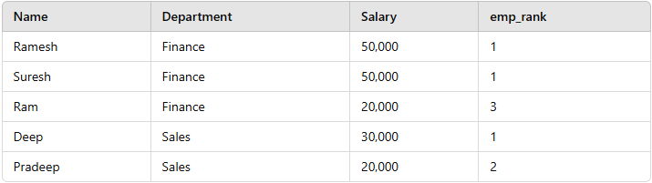
Rank Function Example
Explanation:
- Rows with the same salary (e.g., Ramesh and Suresh) are assigned the same rank.
- The next rank is skipped (e.g., rank 2) due to duplicate ranks.

2. DENSE_RANK() Function
It assigns rank to each row within partition. Just like rank function first row is assigned rank 1 and rows having same value have same rank. The difference between RANK() and DENSE_RANK() is that in DENSE_RANK(), for the next rank after two same rank, consecutive integer is used, no rank is skipped.
Example:
SELECT Name, Department, Salary,
DENSE_RANK() OVER(PARTITION BY Department ORDER BY Salary DESC) AS emp_dense_rank FROM employee;
Output
Name | Department | Salary | emp_dense_rank
Ramesh | Finance | 50,000 | 1
Suresh | Finance | 50,000 | 1
Ram | Finance | 20,000 | 2
Deep | Sales | 30,000 | 1
Pradeep | Sales | 20,000 | 2

3. ROW_NUMBER() Function
ROW_NUMBER() gives each row a unique number. It numbers rows from one to the total rows. The rows are put into groups based on their values. Each group is called a partition. In each partition, rows get numbers one after another. No two rows have the same number in a partition.
Example:
SELECT Name, Department, Salary,
ROW_NUMBER() OVER(PARTITION BY Department ORDER BY Salary DESC) AS emp_row_no FROM employee;

Output
Name | Department | Salary | emp_row_no
Ramesh | Finance | 50,000 | 1
Suresh | Finance | 50,000 | 2
Ram | Finance | 20,000 | 3
Deep | Sales | 30,000 | 1
Pradeep | Sales | 20,000 | 2
Definition of Window Function in SQL
A window function in SQL performs a calculation across a specific range of rows (called a window) that are related to the current row, without collapsing the result into a single output row.
Unlike aggregate functions (SUM(), AVG(), etc.), which group multiple rows into one, window functions retain individual rows while adding computed values based on a defined window of data.
General Syntex:
<window_function>() OVER ( [PARTITION BY column_name]
[ORDER BY column_name])
FAQs
What is a window function in SQL?
A window function in SQL performs a calculation across a set of table rows related to the current row within a specified window. Unlike regular aggregate functions, window functions allow you to retain individual rows while performing the calculation.

3️⃣ Aggregate Window Functions
Perform aggregations across a defined window of rows.
Function | Description
SUM() | Returns cumulative sum over a window.
AVG() | Returns moving average over a window.
MIN() / MAX() | Returns min/max within a window.
COUNT() | Returns count of rows within a window.
📌 Example: Calculate total, average, and highest salary per department.
SELECT EmployeeID, FirstName, Salary, Department,
SUM(Salary) OVER (PARTITION BY Department) AS TotalSalary,
AVG(Salary) OVER (PARTITION BY Department) AS AvgSalary,
MAX(Salary) OVER (PARTITION BY Department) AS MaxSalary
FROM EmployeeSalaries;

What is the window function OVER in SQL?
The OVER clause in SQL defines the window or range of rows the window function should operate on. It is used with functions like ROW_NUMBER(), RANK(), or SUM() to calculate values across a partition of the result set.
What is the window function SQL LAST?
The LAST_VALUE() function in SQL is a window function that returns the last value in a specified window of rows. It allows you to retrieve the last value within a partition, ordered according to the given sorting criteria.
4.Offset (Lag/Lead) Functions
Retrieve values from previous or next rows.
Function | Description
LAG()= | Gets value from the previous row
LEAD()= | Gets value from the next row
Step 1: Creating the Table
CREATE TABLE EmployeeSalaries (
EmployeeID INT PRIMARY KEY,
FirstName VARCHAR(50),
Salary DECIMAL(10,2),
SalaryDate DATE
);
Step 2: Inserting Sample Data
INSERT INTO EmployeeSalaries (EmployeeID, FirstName, Salary, SalaryDate)
VALUES (1, 'Alice', 40000, '2024-01-01'),(2, 'Bob', 45000, '2024-02-01'),
(3, 'Charlie', 50000, '2024-03-01'),(4, 'David', 55000, '2024-04-01'),
(5, 'Emma', 60000, '2024-05-01');
Step 3: Applying LAG() Function
SELECT EmployeeID, FirstName,Salary, SalaryDate,
LAG(Salary) OVER (ORDER BY SalaryDate) AS PrevSalary FROM EmployeeSalaries;
📌 Explanation
- LAG(Salary) retrieves the previous salary value.
- ORDER BY SalaryDate ensures that the salaries are compared sequentially by date.
🔹 Sample Output
EmployeeID | FirstName | Salary | SalaryDate | PrevSalary
1 | Alice | 40000 | 2024-01-01 | NULL
2 | Bob | 45000 | 2024-02-01 | 40000
3 | Charlie | 50000 | 2024-03-01 | 45000
4 | David | 55000 | 2024-04-01 | 50000
5 | Emma | 60000 | 2024-05-01 | 55000
📌 Notice: NULL appears for the first row because there is no previous salary.
Step 4: Applying LEAD() Function
Objective: Get the next salary of each employee.
SELECT EmployeeID, FirstName, Salary,SalaryDate,
LEAD(Salary) OVER (ORDER BY SalaryDate) AS NextSalary
FROM EmployeeSalaries;
📌 Explanation
- LEAD(Salary) retrieves the next salary value.
- ORDER BY SalaryDate ensures correct order.
🔹 Sample Output
EmployeeID | FirstName | Salary | SalaryDate | NextSalary
1 | Alice | 40000 | 2024-01-01 | 45000
2 | Bob | 45000 | 2024-02-01 | 50000
3 | Charlie | 50000 | 2024-03-01 | 55000
4 | David | 55000 | 2024-04-01 | 60000
5 | Emma | 60000 | 2024-05-01 | NULL
📌 Notice: NULL appears in the last row because there is no next salary.

Step 5: Using LAG() and LEAD() Together
We can combine both functions in a single query to compare previous, current, and next salaries.
SELECT EmployeeID, FirstName, Salary, SalaryDate,
LAG(Salary) OVER (ORDER BY SalaryDate) AS PrevSalary,
LEAD(Salary) OVER (ORDER BY SalaryDate) AS NextSalary FROM EmployeeSalaries;
🔹 Sample Output
EmployeeID | FirstName | Salary | SalaryDate | PrevSalary | NextSalary
1 | Alice | 40000 | 2024-01-01 | NULL | 45000
2 | Bob | 45000 | 2024-02-01 | 40000 | 50000
3 | Charlie | 50000 | 2024-03-01 | 45000 | 55000
4 | David | 55000 | 2024-04-01 | 50000 | 60000
5 | Emma | 60000 | 2024-05-01 | 55000 | NULL
📌 Key Insights:
- Each row shows previous and next salaries for easy comparison.
- NULL appears for the first row (no previous salary) and last row (no next salary).
Step-by-Step Execution of Percentile & Cumulative Distribution Functions in SQL
We will go through the entire process, from table creation to query execution with PERCENT_RANK(), CUME_DIST(), and NTILE(4).
Percentile & Cumulative Functions
Useful for percentile analysis, cumulative sums, and moving averages.
Function | Description
PERCENT_RANK() | Returns percentile rank (relative position between 0 and 1).
CUME_DIST() | Returns cumulative distribution (fraction of rows ≤ current row).
NTILE(n) | Divides rows into n equal groups.

📌 Step 1: Creating the Table
First, we create a table called EmployeeSalaries to store employee salary details.
CREATE TABLE EmployeeSalaries (
EmployeeID INT PRIMARY KEY,
FirstName VARCHAR(50),
Salary DECIMAL(10,2)
);
📌 Table Structure:
Column | Data Type | Description
EmployeeID | INT (Primary Key) | Unique ID for each employee.
FirstName | VARCHAR(50) | Employee's first name.
Salary | DECIMAL(10,2) | Employee's salary.

📌 Step 2: Inserting Sample Data
We will insert salary records for multiple employees.
INSERT INTO EmployeeSalaries (EmployeeID, FirstName, Salary)
VALUES (1, 'Alice', 60000),(2, 'Bob', 50000),(3, 'Charlie', 70000),(4, 'David', 40000),
(5, 'Emma', 65000),(6, 'Frank', 45000),(7, 'Grace', 55000),(8, 'Henry', 52000);

📌 Inserted Data:
EmployeeID | FirstName | Salary
1 | Alice | 60000
2 | Bob | 50000
3 | Charlie | 70000
4 | David | 40000
5 | Emma | 65000
6 | Frank | 45000
7 | Grace | 55000
8 | Henry | 52000

📌 Step 3: Executing the Query with Window Functions
Now, we use PERCENT_RANK(), CUME_DIST(), and NTILE(4) to analyze salary distribution
SELECT EmployeeID, FirstName, Salary,
PERCENT_RANK() OVER (ORDER BY Salary DESC) AS PercentileRank,
CUME_DIST() OVER (ORDER BY Salary DESC) AS CumulativeDist,
NTILE(4) OVER (ORDER BY Salary DESC) AS SalaryQuartile
FROM EmployeeSalaries;

📌 Step 4: Understanding the Output
EmployeeID | FirstName | Salary | PercentileRank | CumulativeDist | SalaryQuartile
3 | Charlie | 70000 | 0.0000 | 0.1250 | 1
5 | Emma | 65000 | 0.1429 | 0.2500 | 1
1 | Alice | 60000 | 0.2857 | 0.3750 | 2
7 | Grace | 55000 | 0.4286 | 0.5000 | 2
8 | Henry | 52000 | 0.5714 | 0.6250 | 3
2 | Bob | 50000 | 0.7143 | 0.7500 | 3
6 | Frank | 45000 | 0.8571 | 0.8750 | 4
4 | David | 40000 | 1.0000 | 1.0000 | 4

📌 Step 5: Explanation of Functions
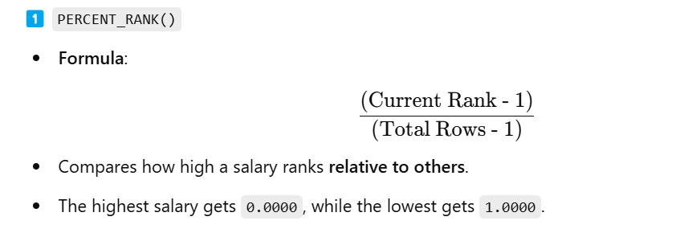

2️⃣ CUME_DIST()
- Formula:
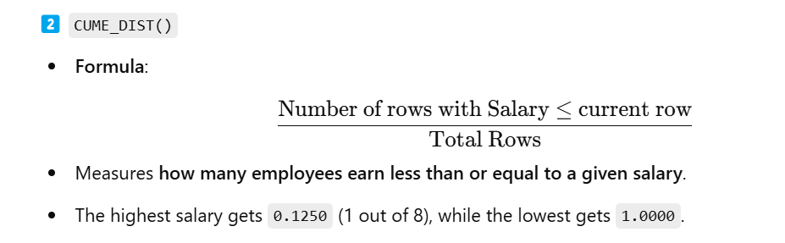3️⃣ NTILE(4)
- Divides employees into 4 equal salary quartiles.
- Quartile 1: Top earners
- Quartile 4: Lowest earners

Pivot and Unpivot in SQL
In SQL, PIVOT and UNPIVOT are powerful operations used to transform data and make it more readable, efficient, and manageable. These operations allow us to manipulate tables by switching between rows and columns, which can be crucial for summarizing data, reporting, and data analysis. Understanding how to use PIVOT and UNPIVOT operators effectively can significantly enhance our data manipulation capabilities.
In this article, we’ll explore what PIVOT and UNPIVOT are, their syntax, key differences, and provide practical examples with explanations to help us master these SQL operations.
What is Pivot in SQL?
The PIVOT operation in SQL allows us to rotate data from rows to columns. This can be particularly useful when we need to summarize, aggregate, or reorganize data for reporting purposes. When we apply PIVOT, each unique value in a column is turned into its own column, and the data is aggregated based on a specified function, such as SUM, AVG, COUNT, etc.
Syntax:
SELECT (ColumnNames)
FROM (TableName)
PIVOT
(
AggregateFunction (ColumnToBeAggregated)
FOR PivotColumn IN (PivotColumnValues)
) AS (Alias)
//Alias is a temporary name for a table
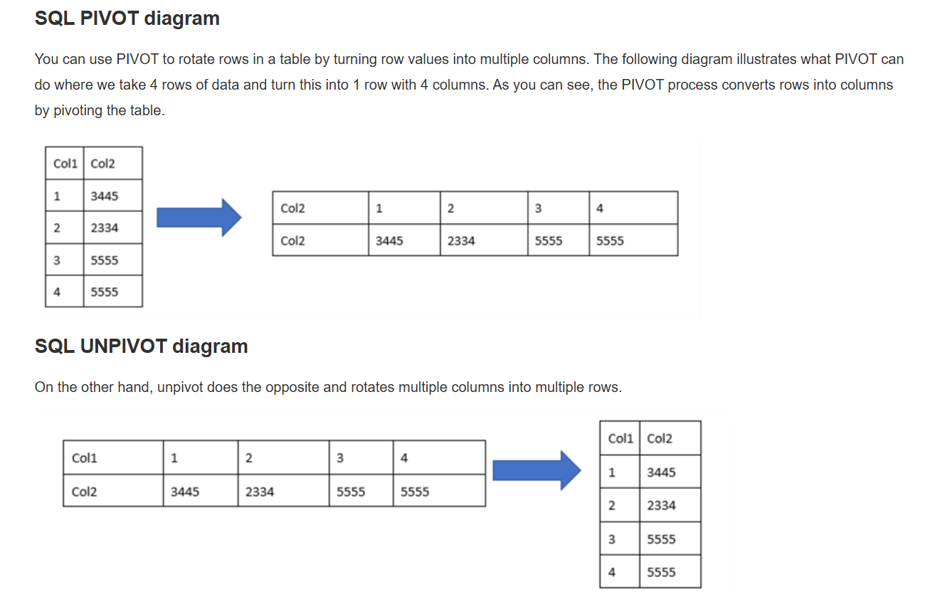
Both, the PIVOT operator and UNPIVOT operator are usually used for reporting purposes when the user requires the information in a different format. However, sometimes, UNPIVOT is used to normalize the output of a query.
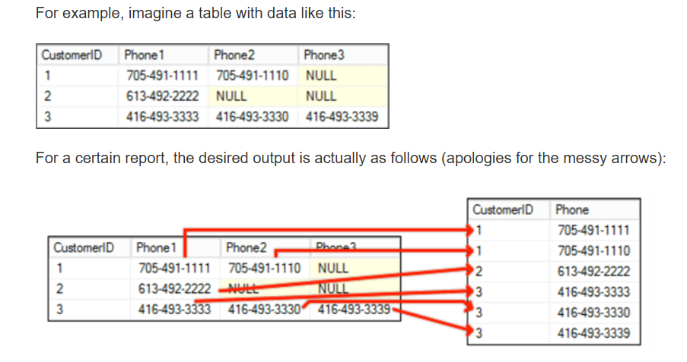
Another scenario is when we want to export data and we need it in a different format and table structure. In those scenarios, we sometimes need to PIVOT or UNPIVOT data.
Pivot and Unpivot in SQL
In SQL, PIVOT and UNPIVOT are powerful operations used to transform data and make it more readable, efficient, and manageable. These operations allow us to manipulate tables by switching between rows and columns, which can be crucial for summarizing data, reporting, and data analysis. Understanding how to use PIVOT and UNPIVOT operators effectively can significantly enhance our data manipulation capabilities.
What is Pivot in SQL?
The PIVOT operation in SQL allows us to rotate data from rows to columns. This can be particularly useful when we need to summarize, aggregate, or reorganize data for reporting purposes. When we apply PIVOT, each unique value in a column is turned into its own column, and the data is aggregated based on a specified function, such as SUM, AVG, COUNT, etc.

Example of Pivot Operation:
Let’s say we have a sample table geeksforgeeks that contains data about various courses, their categories, and their prices. We can use the PIVOT operator to summarize the total price for each course category.
CourseName | CourseCategory | Price
C | PROGRAMMING | 5000
JAVA | PROGRAMMING | 6000
PYTHON | PROGRAMMING | 8000
PLACEMENT 100 | INTERVIEWPREPARATION | 5000
Query:
SELECT CourseName, PROGRAMMING, INTERVIEWPREPARATION
FROM geeksforgeeks
PIVOT
(
SUM(Price)
FOR CourseCategory IN (PROGRAMMING, INTERVIEWPREPARATION )
) AS PivotTable
Output
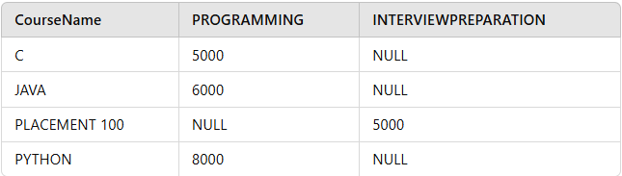
Output of Pivot operation
Explanation:
The PIVOT operation reorganizes the data, transforming the CourseCategory values into columns, while the SUM(Price) function aggregates the prices based on these categories. Notice that the original rows are now represented as columns.
SELECT (ColumnNames) FROM (TableName)
PIVOT
(
AggregateFunction(ColumnToBeAggregated)
FOR PivotColumn IN (PivotColumnValues)
) AS (Alias) //Alias is a temporary name for a table
Use of Aggregation Function in PIVOT and UNPIVOT in SQL
Aggregation functions are essential in PIVOT because they determine how multiple row values are combined into a single column value. UNPIVOT, however, does not require an aggregation function because it converts column values back into rows.
Syntax:
Note: MySQL Does Not Support PIVOT Directly Unlike SQL Server, MySQL does not have a built-in PIVOT function. Instead, you can achieve the same result using CASE statements with GROUP BY.
create database pivot;
use pivot
CREATE TABLE geeksforgeeks (
CourseName VARCHAR(100),
CourseCategory VARCHAR(50),
Price INT
);

INSERT INTO geeksforgeeks (CourseName, CourseCategory, Price) VALUES
('React JS Course', 'PROGRAMMING', 6500),
('Django Full Stack', 'PROGRAMMING', 7200),
('C++ for Beginners', 'PROGRAMMING', 3500),
('Node.js Backend', 'PROGRAMMING', 7800),
-- New Interview Preparation Courses

('Behavioral Interview Tips', 'INTERVIEWPREPARATION', 4500),
('Resume Writing Workshop', 'INTERVIEWPREPARATION', 3200),
('Mock Coding Interviews', 'INTERVIEWPREPARATION', 7000),
('Advanced DSA Problems', 'INTERVIEWPREPARATION', 9000),

-- New Data Science & Machine Learning Courses
('Data Science with Python', 'DATASCIENCE', 8500),
('Machine Learning A-Z', 'DATASCIENCE', 9200),
('Deep Learning with TensorFlow', 'DATASCIENCE', 10500),
('Big Data with Hadoop', 'DATASCIENCE', 8700),

-- New DevOps Courses
('Docker and Kubernetes', 'DEVOPS', 7800),
('AWS Cloud Practitioner', 'DEVOPS', 8200),
('CI/CD with Jenkins', 'DEVOPS', 7500),
('Terraform for Infrastructure', 'DEVOPS', 7900);
select * from geeksforgeeks ;
--------------------------------------------------------------------------------------------------------------------------
-- SELECT CourseName, PROGRAMMING, INTERVIEWPREPARATION
-- FROM geeksforgeeks
-- PIVOT (
-- SUM(Price)
-- FOR CourseCategory IN (PROGRAMMING, INTERVIEWPREPARATION )
-- ) AS PivotTable
--------------------------------------------------------------------------------------------------------------------------
SELECT CourseName,
SUM(CASE WHEN CourseCategory = 'PROGRAMMING' THEN Price ELSE NULL END) AS PROGRAMMING,
SUM(CASE WHEN CourseCategory = 'INTERVIEWPREPARATION' THEN Price ELSE NULL END) AS INTERVIEWPREPARATION
FROM geeksforgeeks GROUP BY CourseName;
--------------------------------------------------------------------------------------------------------------------------
SELECT CourseName,
-- Total price using SUM
AVG(CASE WHEN CourseCategory = 'PROGRAMMING' THEN Price ELSE NULL END) AS Avg_Programming_Price,
AVG(CASE WHEN CourseCategory = 'INTERVIEWPREPARATION' THEN Price ELSE NULL END) AS Avg_Interview_Prep_Price
FROM geeksforgeeks GROUP BY CourseName;
--------------------------------------------------------------------------------------------------------------------------
SELECT CourseName,
-- Maximum price using MAX
MAX(CASE WHEN CourseCategory = 'PROGRAMMING' THEN Price ELSE NULL END)
AS Max_Programming_Price,
MAX(CASE WHEN CourseCategory = 'INTERVIEWPREPARATION' THEN Price ELSE NULL END) AS Max_Interview_Prep_Price
FROM geeksforgeeks GROUP BY CourseName;
SELECT CourseName,
-- Minimum price using MIN
MIN(CASE WHEN CourseCategory = 'PROGRAMMING' THEN Price ELSE NULL END)
AS Min_Programming_Price,
MIN(CASE WHEN CourseCategory = 'INTERVIEWPREPARATION' THEN Price ELSE NULL END) AS Min_Interview_Prep_Price
FROM geeksforgeeks GROUP BY CourseName;
--------------------------------------------------------------------------------------------------------------------------
SELECT CourseName,
-- Count of courses using COUNT
COUNT(CASE WHEN CourseCategory = 'PROGRAMMING' THEN 1 ELSE NULL END) AS Count_Programming_Courses,
COUNT(CASE WHEN CourseCategory = 'INTERVIEWPREPARATION' THEN 1 ELSE NULL END) AS Count_Interview_Prep_Courses
FROM geeksforgeeks GROUP BY CourseName;
--------------------------------------------------------------------------------------------------------------------------
SELECT CourseName,
-- Total price using SUM
SUM(CASE WHEN CourseCategory = 'PROGRAMMING' THEN Price ELSE 0 END) AS Total_Programming_Price,
SUM(CASE WHEN CourseCategory = 'INTERVIEWPREPARATION' THEN Price ELSE 0 END) AS Total_Interview_Prep_Price,
-- Average price using AVG
AVG(CASE WHEN CourseCategory = 'PROGRAMMING' THEN Price ELSE NULL END) AS Avg_Programming_Price,
AVG(CASE WHEN CourseCategory = 'INTERVIEWPREPARATION' THEN Price ELSE NULL END) AS Avg_Interview_Prep_Price,
-- Maximum price using MAX
MAX(CASE WHEN CourseCategory = 'PROGRAMMING' THEN Price ELSE NULL END) AS Max_Programming_Price,
MAX(CASE WHEN CourseCategory = 'INTERVIEWPREPARATION' THEN Price ELSE NULL END) AS Max_Interview_Prep_Price,
-- Minimum price using MIN
MIN(CASE WHEN CourseCategory = 'PROGRAMMING' THEN Price ELSE NULL END) AS Min_Programming_Price,
MIN(CASE WHEN CourseCategory = 'INTERVIEWPREPARATION' THEN Price ELSE NULL END) AS Min_Interview_Prep_Price,
-- Count of courses using COUNT
COUNT(CASE WHEN CourseCategory = 'PROGRAMMING' THEN 1 ELSE NULL END) AS Count_Programming_Courses,
COUNT(CASE WHEN CourseCategory = 'INTERVIEWPREPARATION' THEN 1 ELSE NULL END) AS Count_Interview_Prep_Courses
FROM geeksforgeeks GROUP BY CourseName;
The PIVOT(only support in SQL server) operation reorganizes the data, transforming the CourseCategory values into columns, while the SUM(Price) function aggregates the prices based on these categories. Notice that the original rows are now represented as columns.
1. Pivot Example: Converting Rows to Columns
Scenario:
We have a StudentMarks table that stores marks for students in different subjects.
Student | Subject | Marks
Alice | Math | 85
Alice | Science | 90
Bob | Math | 78
Bob | Science | 88
Goal: Convert subjects into columns.
SQL Query (Pivot)
SELECT * FROM (
SELECT Student, Subject, Marks
FROM StudentMarks
) AS SourceTable
PIVOT ( MAX(Marks) FOR Subject IN ([Math], [Science]) ) AS PivotTable;
Since MySQL does not support PIVOT, we can achieve the same result using conditional aggregation (CASE WHEN).
✅ Corrected Query for MySQL:
SELECT Student,
MAX(CASE WHEN Subject = 'Math' THEN Marks ELSE NULL END) AS Math,
MAX(CASE WHEN Subject = 'Science' THEN Marks ELSE NULL END) AS Science
FROM StudentMarks GROUP BY Student;
Result:
Student | Math | Science
Alice | 85 | 90
Bob | 78 | 88

What is Unpivot in SQL?
The UNPIVOT operation in SQL is the reverse of PIVOT. It allows us to convert columns back into rows, which can be useful when we need to normalize or restructure data after performing a pivot operation. UNPIVOT helps in data analysis where row-based operations are required for analysis.
Syntax:
SELECT (ColumnNames)
FROM (TableName)
UNPIVOT
(AggregateFunction(ColumnToBeAggregated)
FOR PivotColumn IN (PivotColumnValues)
) AS (Alias)
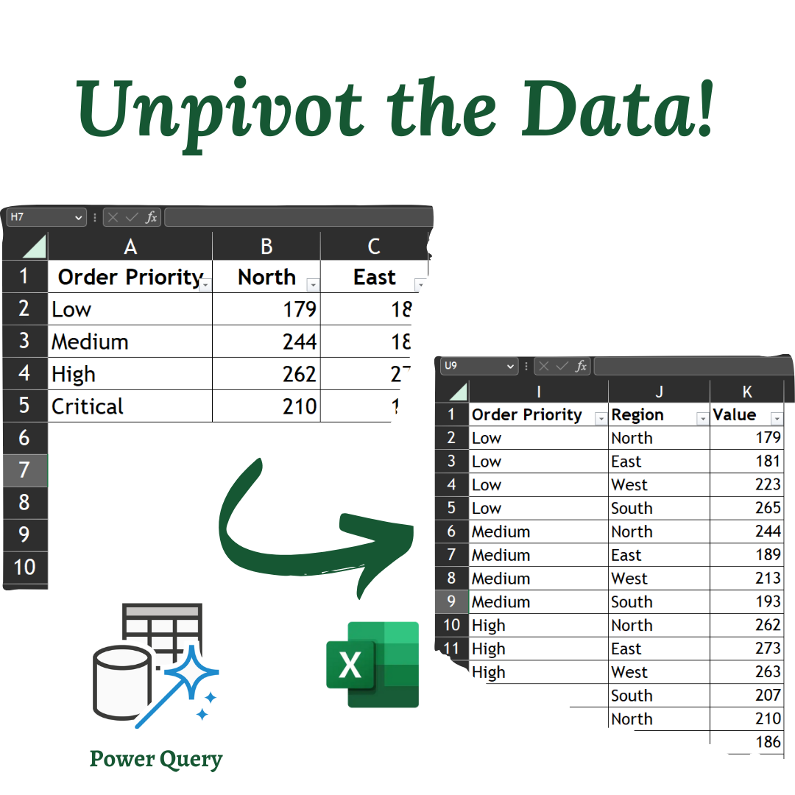
Example of Unpivot Operation:
Now, we use the same table “geeksforgeeks” created in the above example and apply the UNPIVOT operation to reverse the PIVOT operation above and retrieve the original data.
Query:
SELECT CourseName, CourseCategory, Price
FROM
(
SELECT CourseName, PROGRAMMING, INTERVIEWPREPARATION
FROM geeksforgeeks
PIVOT
(
SUM(Price)
FOR CourseCategory IN (PROGRAMMING, INTERVIEWPREPARATION)
) AS PivotTable
) AS P
UNPIVOT
(
Price FOR CourseCategory IN (PROGRAMMING, INTERVIEWPREPARATION)
) AS UnpivotTable;
Output
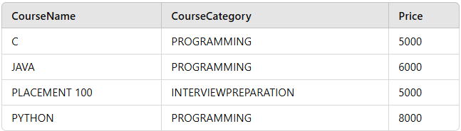
Output of Unpivot operation
The UNPIVOT operation transforms the column-based data (PROGRAMMING and INTERVIEWPREPARATION) back into rows, allowing us to return to the original structure. It essentially reverts the result set from the PIVOT operation.
When to Use Pivot and Unpivot in SQL
- PIVOT: When you need to summarize or aggregate data and display it in a columnar format, typically for reporting purposes.
- UNPIVOT: When you need to convert column data back to rows, often after performing a PIVOT operation, for normalization or further analysis.
PIVOT and UNPIVOT in Power Query (Excel & Power BI)
Power Query provides PIVOT and UNPIVOT functions to reshape data efficiently.

🔹 PIVOT in Power Query
📌 What It Does:
- Converts unique values from a column into new column headers.
- Aggregates values where necessary.
✅ Example - PIVOT Transformation:
Input Data (Sales Data)
Product | Month | Sales
Laptop | Jan | 5000
Laptop | Feb | 6000
Phone | Jan | 7000
Phone | Feb | 7500
🎯 Goal: Convert Month values into separate columns.
PIVOTED Output (After Pivoting "Month" Column)
Product | Jan | Feb
Laptop | 5000 | 6000
Phone | 7000 | 7500
🛠 Steps to PIVOT in Power Query:
- Load the data into Power Query (Excel/Power BI).
- Select the column to pivot (Month).
- Click Transform → Pivot Column.
- Choose Values Column (Sales).
- Select Aggregation (default is SUM).
- Click OK to apply.

🔹 UNPIVOT in Power Query
📌 What It Does:
- Converts multiple columns into rows.
- Useful when data is stored in a wide format and needs normalization.
✅ Example - UNPIVOT Transformation:
Input Data (Wide Format)
Product | Jan | Feb
Laptop | 5000 | 6000
Phone | 7000 | 7500
🎯 Goal: Convert Jan & Feb columns into a single column named Month.
UNPIVOTED Output (After Unpivoting "Jan" & "Feb" Columns)
Product | Month | Sales
Laptop | Jan | 5000
Laptop | Feb | 6000
Phone | Jan | 7000
Phone | Feb | 7500
🛠 Steps to UNPIVOT in Power Query:
- Load the wide data into Power Query.
- Select multiple columns (e.g., Jan, Feb).
- Click Transform → Unpivot Columns.
- Rename the generated Attribute column to Month.
- Rename Value column to Sales.

📌 Summary of PIVOT vs. UNPIVOT
Feature | PIVOT | UNPIVOT
What it does | Converts rows into columns | Converts columns into rows
Use case | Makes data wider (summary tables) | Makes data longer (normalization)
Common Application | Monthly sales reports, survey results | Converting multi-period data for analysis

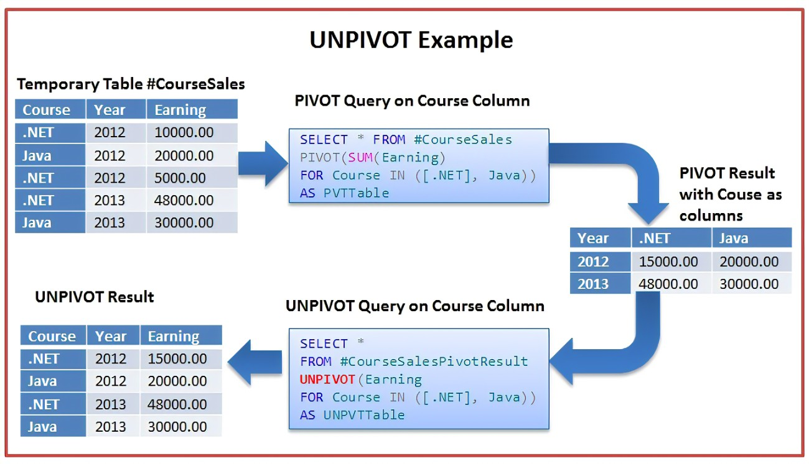
Example-1:
CREATE TABLE StudentMarks_Pivot (
Student VARCHAR(50),
Math INT,
Science INT,
English INT
);
select * from StudentMarks_Pivot;
INSERT INTO StudentMarks_Pivot (Student, Math, Science, English)
VALUES
('Alice', 85, 90, 88),
('Bob', 78, 88, 80),
('Charlie', 92, 95, 89),
('David', 75, 85, 82),
('Eve', 88, 91, 87),
('Frank', 79, 83, 81),
('Grace', 94, 97, 90),
('Hannah', 80, 89, 85), ('Isaac', 82, 84, 78), ('Jack', 90, 92, 88);
-- SELECT Student, Subject, Marks
-- FROM
-- (SELECT Student, Math, Science, English FROM StudentMarks_Pivot) AS SourceTable
-- UNPIVOT
-- (Marks FOR Subject IN (Math, Science, English))
-- AS UnpivotTable;
-- MySQL does not support UNPIVOT, but you can achieve the same result using UNION ALL:
SELECT Student, 'Math' AS Subject, Math AS Marks FROM StudentMarks_Pivot
UNION ALL
SELECT Student, 'Science' AS Subject, Science AS Marks FROM StudentMarks_Pivot
UNION ALL
SELECT Student, 'English' AS Subject, English AS Marks FROM StudentMarks_Pivot;

-- Variable Type Description
------------------------------------------------------------------------------------------------------------
-- Student Column The student's name (taken directly from StudentMarks_Pivot)
-- Math Column Math marks for each student (from StudentMarks_Pivot)
-- Science Column Science marks for each student (from StudentMarks_Pivot)
-- English Column English marks for each student (from StudentMarks_Pivot)
-- 'Math' Constant (String) A fixed value assigned as the Subject in the first SELECT
-- 'Science' Constant (String) A fixed value assigned as the Subject in the second SELECT
-- 'English' Constant (String) A fixed value assigned as the Subject in the third SELECT
=====================================================
-- 1)First SELECT Block:
-- SELECT Student, 'Math' AS Subject, Math AS Marks FROM StudentMarks_Pivot
-- Selects Student name
-- Assigns 'Math' as the Subject (a constant value)
-- Retrieves Math marks from StudentMarks_Pivot
======================================================= 2)Second SELECT Block (Using UNION ALL):
-- UNION ALL
-- SELECT Student, 'Science' AS Subject, Science AS Marks FROM StudentMarks_Pivot
-- Selects the same Student column
-- Assigns 'Science' as the Subject (a constant value)
-- Retrieves Science marks
====================================================
-- 3)Third SELECT Block (Using UNION ALL):
-- UNION ALL
-- SELECT Student, 'English' AS Subject, English AS Marks FROM StudentMarks_Pivot;
-- Again selects Student
-- Assigns 'English' as the Subject
-- Retrieves English marks
=======================================================
-- Fixed values ('Math', 'Science', 'English') are used to convert columns into rows.
-- Columns (Student, Math, Science, English) are used to fetch data from the table.
-- UNION ALL is used to combine the results into a single output.
=======================================================
-- unpivoted supported query in SQL
-- --------------------------------------------------------------------------------------------------------
-- SELECT Student, Subject, Marks
-- FROM
--(SELECT Student, Math, Science, English FROM StudentMarks_Pivot) AS SourceTable
-- UNPIVOT
-- (Marks FOR Subject IN (Math, Science, English)) AS UnpivotTable;

Example-2:
CREATE TABLE CourseEarnings (
Course VARCHAR(50),
Year_2022 INT,
Year_2023 INT,
Year_2024 INT
);

INSERT INTO CourseEarnings (Course, Year_2022, Year_2023, Year_2024) VALUES
('Python Basics', 5000, 7000, 8500),
('Java Masterclass', 7000, 9500, 12000),
('Data Science', 8000, 11000, 13000),
('SQL Bootcamp', 4500, 6000, 7500),
('Web Development', 9000, 10500, 12500),
('AI & ML', 10000, 13000, 15000),
('Cyber Security', 7500, 9200, 11000),
('Cloud Computing', 8800, 10200, 11800),
('Blockchain Basics', 7200, 8500, 9800),
('Digital Marketing', 6800, 8200, 9400);

-- Step 3: Apply UNPIVOT (SQL Server)
-- To convert years from columns into rows, we apply UNPIVOT:
=======================================================
-- SELECT Course, Year, Earnings
-- FROM
-- (SELECT Course, Year_2022, Year_2023, Year_2024 FROM CourseEarnings) AS SourceTable
-- UNPIVOT
-- (Earnings FOR Year IN (Year_2022, Year_2023, Year_2024))
-- AS UnpivotTable;

SELECT * from CourseEarnings;
-- Step 3: Apply UNPIVOT (SQL Server)
-- To convert years from columns into rows, we apply UNPIVOT:
=======================================================
-- To convert years from columns into rows, we apply UNPIVOT:
-- SELECT Course, Year, Earnings
-- FROM
-- (SELECT Course, Year_2022, Year_2023, Year_2024 FROM CourseEarnings) AS SourceTable
-- UNPIVOT
-- (Earnings FOR Year IN (Year_2022, Year_2023, Year_2024))
-- AS UnpivotTable
=======================================================
-- Alternative for MySQL (Since UNPIVOT is Not Supported)

-- If you're using MySQL, use UNION ALL:
SELECT course,'Year_2022' as Year,Year_2022 as Earning from CourseEarnings
UNION ALL
SELECT course,'Year_2023' as Year,Year_2023 as Earning from CourseEarnings
UNION All
SELECT course,'Year_2024' as Year,Year_2024 as Earning from CourseEarnings
FAQs:
What is the difference between pivot and unpivot in SQL?
In SQL, PIVOT transforms rows into columns, summarizing data, while UNPIVOT converts columns back into rows, useful for data normalization.
What is a pivot query in SQL?
A PIVOT query in SQL rotates data from rows to columns, typically used to aggregate data and create more readable reports.
What is the difference between pivot and unpivot in Power Query?
In Power Query, PIVOT turns unique values from a column into multiple columns, while UNPIVOT does the reverse, converting columns into rows

